Luis Garcia

CAP-4104

Gregory M Reis

September 24, 2022

Project I

1. **Violations of Usability Goals and Design Principles:**

* **Efficiency:**

**The absolute lack of structure is what destroys this website’s efficiency. At first glance, the user of the website might wonder, is this a legit website? Or am I about to download malware into my machine? Once the user determines its legitimacy, they proceed to piece together each title with its corresponding paragraph panel to decipher the information provided like a puzzle. The lack of consistency, the unique use of solid color and grading color in panels, and the unpleasant use of small letter font makes it a hassle for the user to navigate this website.**

* **Learnability:**

**Every new user might argue that an instruction manual needs to be issued to each user to navigate this website. It takes an unusual amount of time to get acquainted with the structure and the information displayed on the home page. For instance, a student might have difficulties learning that they actually can create a profile to log in into this website since the Log in panel is located at the bottom of the left panels because this location is simply not standard for this specific feature. Learning each panel, buttons, and hyperlinks is an actual chore that inconveniences the user experience.**

* **Memorability:**

**Memorability goes hand-and-hand with learnability. If a user might struggle to learn how to use and navigate a website, then it is only natural for them to struggle again as a returning user. Just leaning the actual organization of the website is a colossal task on its own, one might struggle to put into words how difficult it might be to recall all that information once needing to use this website again.**

* **Visibility:**

**Yale’s School of Art’s website surprisingly offers a complete array of features including the ability for the user to create a profile either as a student or as a regular user, it offers access to their virtual art exposition, and it displays a schedule for all the activities that they are hosting, but are these features easy to locate? Unfortunately for the user, it is a tedious task to find these features as the lack of structure and inconsistencies makes it difficult to understand which bottom does which feature.**

* **Consistency:**

**It’s lack of consistency its easily its biggest sin. Almost all panel have a different color pallet and grading, the main information is not centered inside of its main panel, almost all text is written in a different font and different font size, some texts are highlighter while other pieces of texts are not. The list of inconsistencies goes on and on meaning that this website needs a complete overhauling.**

* **Affordance:**

**Located on the left set of panels under the Menu panel there is a random yellow button displaying “Pause Animation” text inferring that this button allows the user to pause a certain animation, yet the website is completely static. Upon clicking on this button, the complete page reloads yet there is no visible change. The uncertainty that this button causes to the user experience results in a decrease in the website legitimacy. Once the user starts clicking on different buttons, they will discover that the background changes to an actual animation depending on which menu you click on meaning that now the pause animation button can be useful in some way. The lack of clarity about this button’s actual use hurts the website’s affordance. In my opinion, this button should be completely removed along with the background animations.**

1. **Goal Identification:**
   1. Target audience. Who is the site or app for?

The audience of Yale’s School of Art website is mostly composed of art students ranging in between the ages of 18 to 26, and it is also composed of artists raging from the age of 26 and above.

* 1. What do they expect to find or do there? What is the objective of this website or app?

The Yale School of Art website is designed, in a strange manner, to educate students seeking information regarding the services offered by the Art division of Yale and news related to the art world or School related information. It is also catering art expositions for those people belonging to the art industry.

* 1. Is this website or app’s primary aim to inform, to sell, or to amuse?

As it is stated directly on the website, it’s primary aim is to publish digital content and artwork and sharing information and news related to any topic within the art industry. To rephrase it, this website is designed to inform and amusement purposes.

* 1. Does the website or app need to clearly convey a brand’s core message, or is it part of a wider branding strategy with its own unique focus?

Yale’s mission statement tells that “Yale is committed to improving the world today and for future generations through outstanding research and scholarship, education, preservation, and practice”. Being Yale’s division of art, they are bound to reflect Yale’s commitment for excellence in education and to follow its prestigious reputation. Therefore, this website should clearly convey Yale’s core message.

* 1. What competitor sites or apps, if any, exist, and how should this site or app be inspired by/different than, those competitors?

There are eight institutions ranked among the best universities worldwide including Brown, Cornell, Harvard, Columbia, Dartmouth, University of Pennsylvania, Princeton, and Yale. Most of them offering a great Art program, these institutions are naturally Yale’s direct competitors. Most of these Universities’ Art School websites are outstanding compared to Yale’s University. Using Brown University’s, and Harvard University’s as a reference, these websites are well structured, or concise enough to an extent where Yale’s School of Art website cannot be compared.

1. **Redesign:**

The Header

Redesign:

Original Design:

This website needs a complete overhaul. For its header, I decided to work with Yale’s classic colors white and blue. At the top of the redesigned header, we have the name of the school including its address as it can be observed in the original designed. The font used is consistent across the website, and I decided to use solid coloring instead of graded coloring of the panels to keep consistency. The logo of the school was added to the redesigned header on the top left as it is usually its standard location as well. The Menu panel and the Quick links drop down menu have been combined into a single well-centered all-purpose menu displaying the same information with drop down options as well.

As we can observe, the log in option is nowhere visible in the original design even though this feature is actually available. For the redesign, I decided to use a drop-down menu located in its standard right top of the page in a solid darker blue color. It drops down to enable the options of registering, login in as a student or as a visitor. Lastly I decided to add the option to search any keywords.

The Body

Redesign:

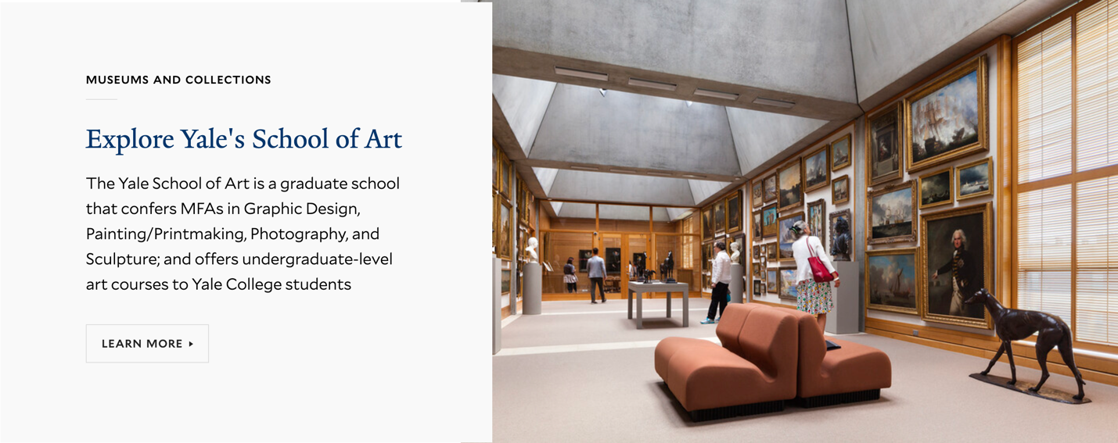

Original Design:

For the body of the redesign, I decided to keep it simple and consistent. Again, I used Yale’s school colors white and blue with a solid background color. The overwhelming amount of disorganized information displayed in the original designed has been rearranged to only display the introductory information found on the yellow panel. If the user were to require more information about the page, they would click on the Learn More button to access this extra information. Half of the redesign body page consist of actual text, while the other half consist of an actual photo of one of Yale’s Art Museum to add visual elements lacking in the original design. The Pause Animation button found on the original design has been eliminated along with the actual animations of the background.

Redesign:

Original Design:

Continuing with the body section of the page, I have decided to make a proper use of the space of the page by combining the News section with the Event Schedule section. On the redesign, it displays the featured new of the day with minimalistic text and a decent size image. On the left-hand side, the user can find an interactive schedule of the art event schedule hosted by the Yale School of Art. The color, font, and the structure follow the same format as we have observed with sections of the redesign enhancing the overall consistency and improving learnability and memorability with its simplicity.